The STAR Method for Finance Interviews: Examples That Actually Land
Meta description: The STAR method for finance interviews: what each part does, how to split 90 seconds, four worked answers to bank questions, and fixes for common mistakes.

The STAR method is a four-part structure for answering behavioral interview questions: Situation, Task, Action, Result. Deloitte, PwC and Bank of America tell candidates to use it by name, and JPMorgan's own interview handbook teaches the same shape under different letters. In a HireVue you get about 30 seconds to think and about two minutes to talk, so it helps to have the structure down before the first question appears.

In this article, I lay out what each part does, how to split the time, how to prepare about five stories, four worked answers, how to handle a recorded HireVue, and the mistakes that usually cost the most.

What does STAR stand for in an interview?
STAR stands for Situation, Task, Action, Result. You set the scene in a sentence or two, say what you were responsible for, spend most of the answer on what you did, and close with what happened, with a number if you have one. Most variants a bank teaches keep the same three moves: the problem, what you did, and what happened.

Some banks teach other letters, such as CAR or STARR, and JPMorganChase's digital handbook uses CAR, so pick one and stick with it.

How long should a STAR method answer be?
Between 60 and 120 seconds, and 90 seconds is a good target to practice to. Mergers & Inquisitions puts a 90-second answer at about 150 words, with 180 to 190 as the ceiling, and the University of Maryland's Smith School and Wall Street Oasis both say to keep every answer under two minutes. The Situation is the part that grows when an answer runs long.

1. Spend most of your 90 seconds on the Action
MIT's career office splits the time as Situation 20 percent, Task 10 percent, Action 60 percent and Result 10 percent, so in a 90-second answer the Action gets 54 seconds.

Here's what each part is for, and about how long it gets in a 90-second answer. The snippets come from one story, a student fund pitch that went wrong, so you can see the pieces before the full answer in section 3.

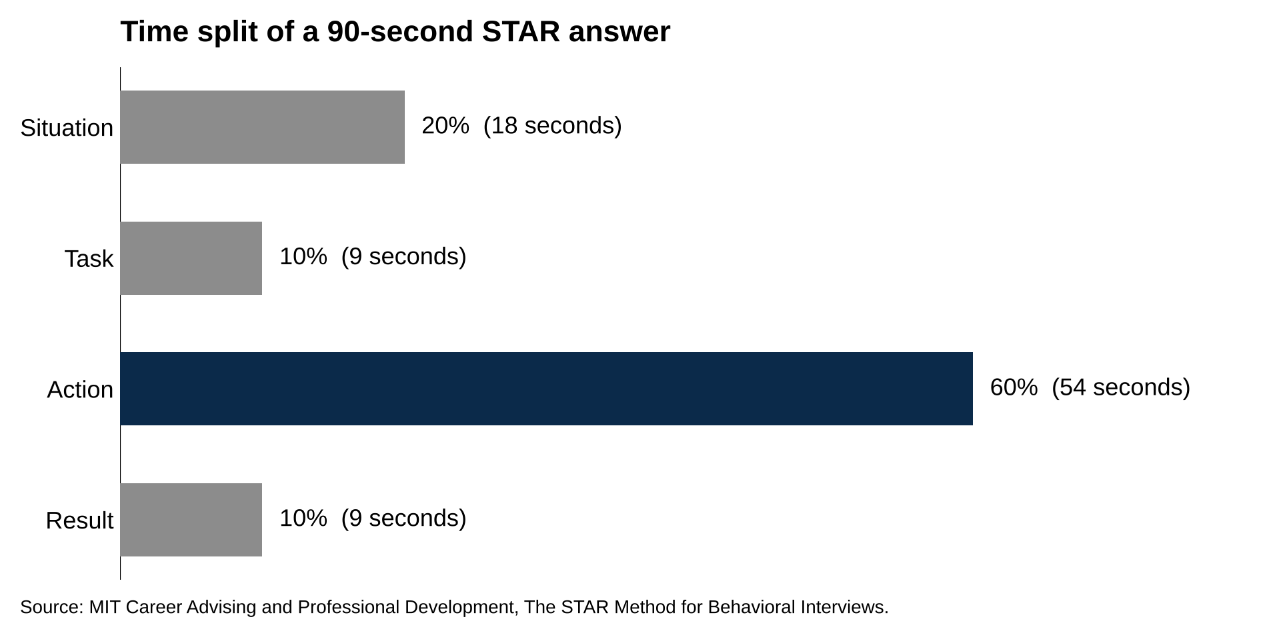
The Action gets 60 percent of the answer, about 54 seconds of 90.
Source: MIT Career Advising and Professional Development, The STAR Method for Behavioral Interviews; seconds are WSG's arithmetic on a 90-second answer.

The Situation gets about 18 seconds, two sentences, for where you were, when, and what the problem was. "Last spring I was one of four analysts on a pitch team at my school's student-run fund. Two days before the committee vote, the chair flagged that our revenue model was growing faster than the company's own guidance." That's the whole Situation. It skips how you joined the fund and what the company sells, because the listener doesn't need either one to follow the problem. As MIT's guide puts it, the interviewer does "not need to know every detail."

The Task gets about 9 seconds, one sentence, for what you specifically were responsible for. "My job on the team was the model, so the error was mine to find." The Task is where the "I" starts. Deloitte's recruiters put it plainly: "Even in a team example, we're assessing your individual capability." Keep the Task to your responsibility or goal and save the steps for the Action. IGotAnOffer notes that candidates often blur the two, and an answer that starts acting in the Task usually ends up telling the same steps twice. If you weren't formally in charge, say what you took on: "I offered to rebuild the model."

The Action gets about 54 seconds, four to six sentences, because it's the part interviewers usually care most about. The Action is what you did, in the order you did it, with the decisions along the way. "I went back to the last three 10-Ks and rebuilt revenue by segment instead of taking the total from a data provider." One decision per sentence, in order, with the reason when it isn't obvious, because the reason is what shows judgment.

Each step should be specific enough that the listener can picture it. "I looked into the model and fixed it" gives them nothing to picture or ask about, while "I went back to the last three 10-Ks" does. Two to four steps usually fill the time. The reason can be short: in the full answer in section 3, "so he could defend it without me" is the whole reason for walking the senior analyst through the changes, and it shows you were thinking about the committee, not only the spreadsheet.

The Result gets about 9 seconds, one or two sentences, and it carries the number. "The corrected model cut our price target by 11 percent, and the pitch passed the following week." Then stop. The number doesn't have to be a dollar figure. A percentage, a count, a deadline beaten, a round advanced or a before and after all work, and the four answers in section 3 use each of those. Harvard's career office tells students to "have a conclusion," meaning the outcome or what you learned. A one-line lesson fits best when the question asked about a failure or feedback, as in the first answer below. On other questions, the number usually makes the better ending.

2. Five stories usually cover most questions
MIT tells students to prepare three to five stories. For banking, five usually works well, because the behavioral questions that prep sites and career offices list for bank interviews mostly sort into five types: a failure, a team project, a conflict, a time you led or changed a mind, and an analysis.

Each story works best as one specific event from the last two years, from a different setting than the other four, with a number in the Result. A specific event means one project or one week, not a description of what you generally do. Different settings let the interviewer see range rather than one club told five ways. The number rules out some stories before you start, and a student fund, a Research Challenge team or a club budget usually gives you a number, a team and a deadline built in.

To find them, go down your resume one line at a time. For each job, club or class project, write down any moment where something went wrong, you had to make a call, or you changed how something was done. Harvard's guide says examples can come from work, school, activities or volunteering, so a part-time job counts as much as a finance club. Keep the five that fit the types below and have the clearest number, and hold the rest as backups.

Then draft each one in two passes. First write four lines, one per letter: the setting and the problem, your job, your two to four steps, and the number. If a line is hard to fill, the story may not be ready yet (a thin Task line often means it was really someone else's project). Then write it out in full at about 150 words. Penn's career office suggests telling it to someone who doesn't know the situation and asking what they took away. If they can't say what you did and how it ended, the Action or the Result needs more detail.

Here are the five types, with a few of the questions each one tends to answer:

- A failure you fixed: "Tell me about a time you failed," "Tell me about difficult feedback you received," "Tell me about a time you showed resilience."
- A team project you carried a piece of: "Tell me about a time you worked in a team," "Tell me about a project with a tight deadline," "Tell me about a time you had to learn quickly."
- A conflict you resolved: "Tell me about a time a team member wasn't pulling their weight," "Tell me about a disagreement in a group," "Tell me about a difficult client."
- A time you led or changed someone's mind: "Tell me about a time you demonstrated leadership," "Tell me about a time you were persuasive," "Tell me about a time you influenced without authority."
- An analysis that changed a decision: "Tell me about a time you used data to make a recommendation," "Tell me about a time your manager questioned your decision."

If an interviewer asks two questions that fit the same story, don't tell it twice. Asked for a failure and then for resilience, tell your failure story, and have your team project ready in case they push for a second example.

Most banks also publish their values (Goldman Sachs, Morgan Stanley and JPMorganChase, on its How We Hire page, each have a public list), and an interviewer will often be listening for them. Skim the list for each bank you're interviewing with and pick the story that fits.

3. Four STAR method answers to common bank questions
Each answer below is written the way the candidate would say it, in the first person. Each one runs 150 to 190 words, which is roughly 90 seconds out loud, and each Result carries a number. The settings are the ones on a typical sophomore or junior resume: a student fund, a Research Challenge team, a club and a part-time job.

Swap in your own details and keep the shape.

Tell me about a time you failed and how you overcame it

"Last spring I was one of four analysts on a pitch team at my school's student-run fund. Two days before the committee vote, the chair flagged that our revenue model was growing faster than the company's own guidance. My job on the team was the model, so the error was mine to find. I went back to the last three 10-Ks and rebuilt revenue by segment instead of taking the total from a data provider. The problem was a reseller channel. The company reports it inside its direct sales line, and I had added it on top as a separate segment, so about 15 percent of revenue was counted twice. I corrected the build, re-ran the valuation, and walked our senior analyst through every change before the committee saw it, so he could defend it without me. The corrected model cut our price target by 11 percent. The pitch went back to committee the following week, passed, and the fund took a 2 percent position. Since then I build revenue from the filings first and use the data provider only as a check."

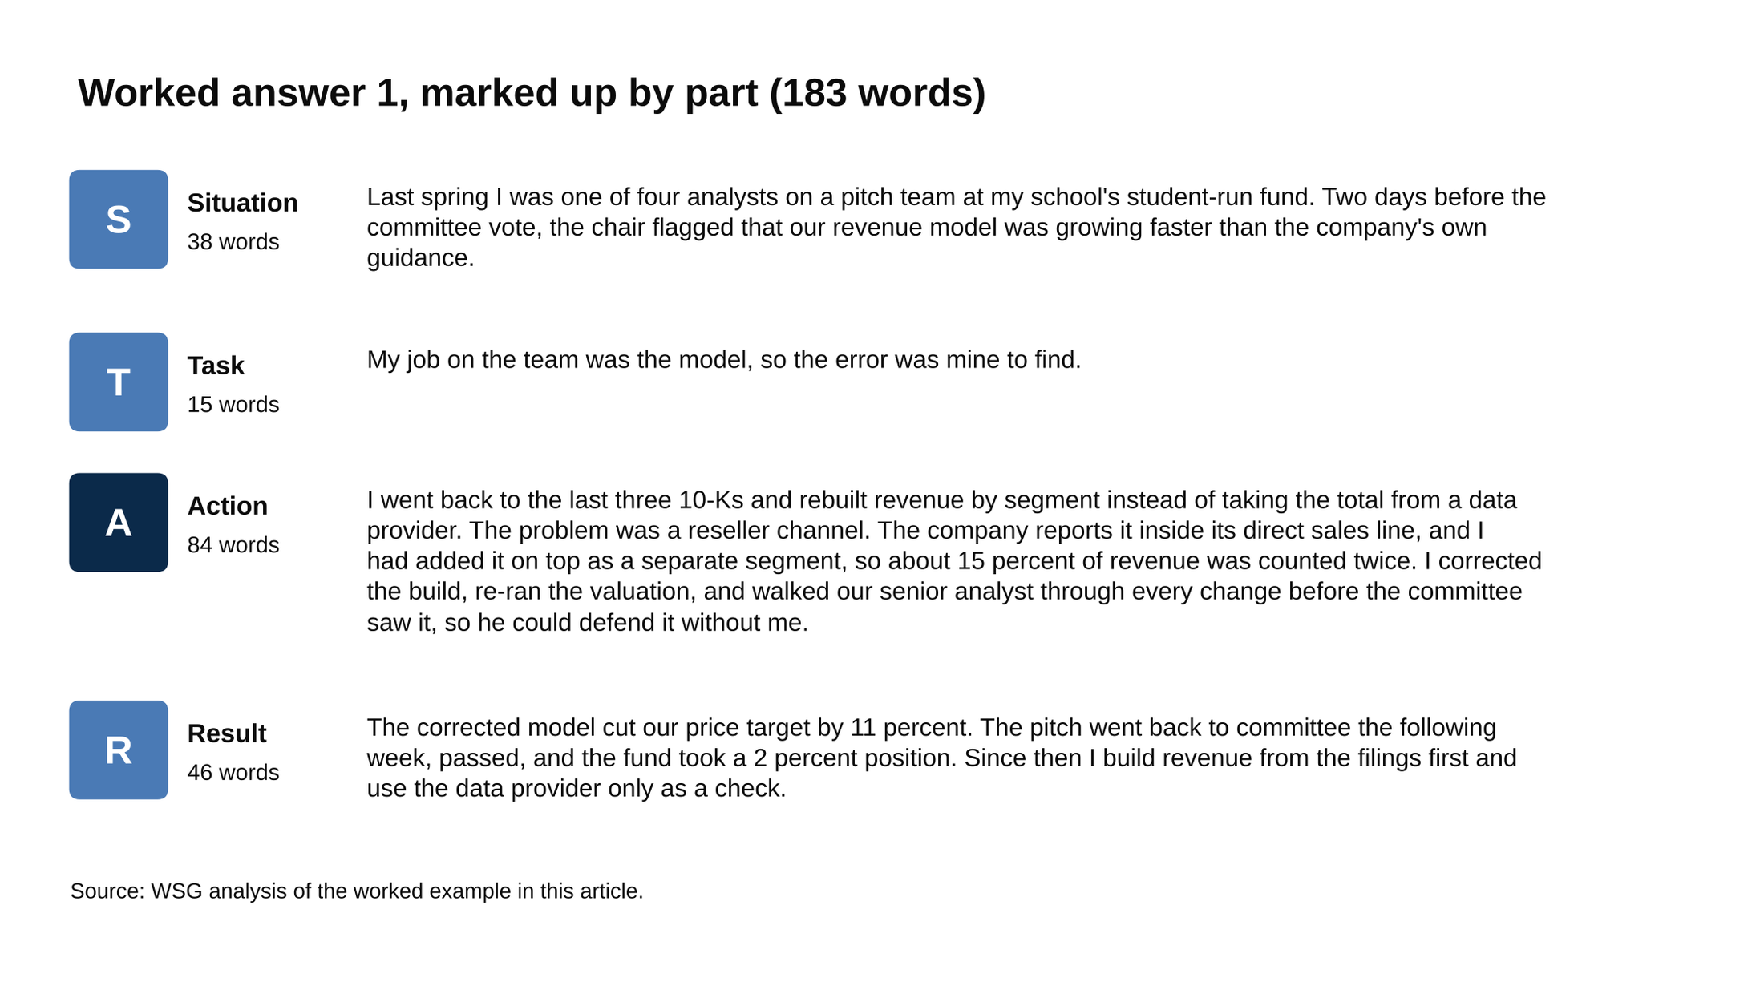
The Action runs 84 of the answer's 183 words, the Situation 38.
Source: WSG analysis of the worked example in this article.

Tell me about a time a team member wasn't pulling their weight. What did you do?

"In the fall I was on a five-person CFA Research Challenge team covering a regional bank. We split the report into five sections, and the teammate with the valuation section missed two internal deadlines in a row, so three weeks before submission we had no price target. I was leading the report, so it was on me to fix it. I asked him directly what was going on. He had two midterms and a job interview in the same week and had been embarrassed to say so. We agreed on a split: I took the discounted cash flow build that week, he took the comparable companies work the week after, and we set a 20-minute check-in every Tuesday until submission. I also sent the rest of the team an updated timeline so nobody was guessing where the valuation stood. We submitted two days early with a full valuation section, and the team advanced out of the local round to the sub-regional. He stayed on for the presentation and handled the comps questions from the judges himself."

In a conflict answer, it helps to show you found out why before you fixed anything, and this Action does that in its first step, before the new split or the check-ins.

Tell me about a time when you demonstrated leadership

"I was elected treasurer of my school's investment club at the start of my sophomore year. The club had about $1,200 in its account and had already promised members three events: an alumni panel, a stock pitch competition with prizes, and a trip to visit two firms in the city. Priced out, the three came to about $2,000. My job was to deliver all three without asking the school for an emergency grant. I started with what didn't need money. I moved the panel from a catered room to a lecture hall the department let us use for free, which saved about $400. For the pitch competition, I replaced the cash prizes with a sponsorship from a local wealth management firm, which put up $500 in prizes in exchange for a table at the event. For the trip, I negotiated a group rate on the train and asked members to cover their own tickets, with the club paying for the four who said they couldn't. All three events ran, the panel drew about 90 people, and we ended the year with $300 in the account."

Leadership here is three decisions with a dollar figure on each, not a title.

Tell me about a time you used data to make a recommendation

"I worked about ten hours a week at a coffee shop on campus during my sophomore year. The manager was frustrated by how much food we threw out at closing, and since I logged the waste sheet, she asked me to look at it. My task was to find where the waste was coming from and suggest a fix she could put in place without hiring anyone. I pulled eight weeks of the waste log and the daily sales reports and put them side by side in a spreadsheet. The pattern was clear once it was in one place: we ordered the same number of pastries every day, but Tuesday and Wednesday sales were about 40 percent lower than Monday and Thursday, so almost all the waste was midweek. I recommended cutting the midweek pastry order by a third and leaving the rest alone, and built a one-page sheet she could update weekly to see whether it was working. She made the change the next week. Waste fell from about $90 a week to about $35, and the midweek sellouts she worried about never happened."

4. The STAR method in a recorded HireVue
At Goldman Sachs and JPMorgan, the first round is a recorded HireVue, the one-way video interview where questions appear on screen and you talk to your camera. Goldman's student prep page says the video interview takes about 30 minutes and that candidates who pass it go to a final round of two to five interviews. The format is often three to six questions, with about 30 seconds to prepare and up to about two minutes to answer each, and retakes vary by firm, so check the screen before the first question, which shows how many attempts you get. [VERIFY: Goldman and JPMorgan HireVue question count, prep and answer times, and retake setting for the current cycle]

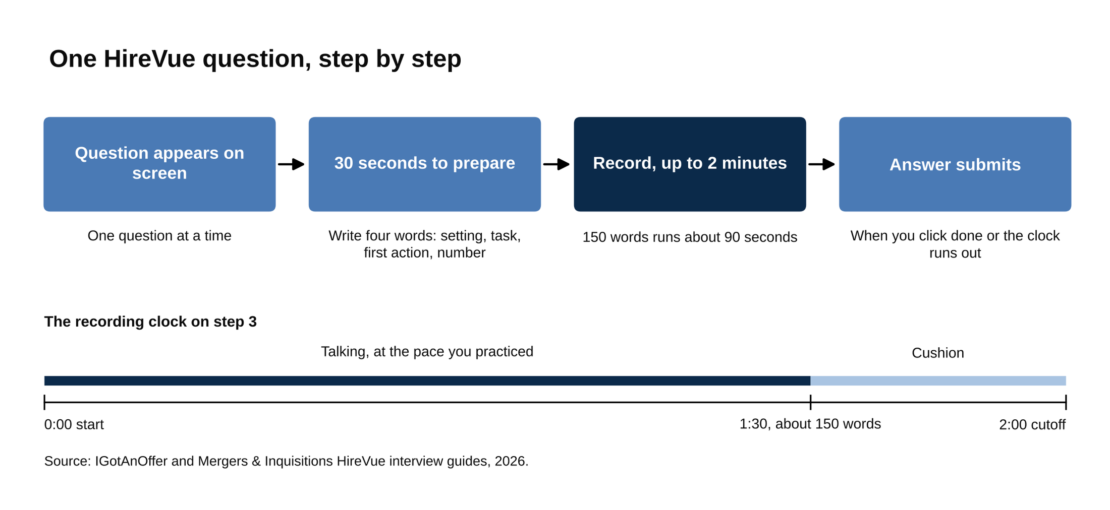
Each question gives about 30 seconds to prepare and up to two minutes to record.
Source: IGotAnOffer and Mergers & Inquisitions HireVue interview guides, 2026.

Practice until the STAR structure comes without thinking, because the prep window in a HireVue is only about 30 seconds. Thirty seconds is enough to write four words on a notepad next to your laptop: the setting, your task, the first action, the number at the end. The question usually tells you which of your five stories to pull, so the prep window is for matching, not inventing. Then talk to the camera at the pace you practiced. At 150 words you'll finish around 90 seconds, which leaves a cushion before a two-minute cutoff. If you finish early, click the done button instead of filling the time. The answer submits when the clock runs out or when you click, and adding more after your Result rarely helps.

HireVue also gives you practice questions before the real ones. Its candidate guide says you can repeat them until you're comfortable, and its help center says practice recordings are never sent to the employer. [VERIFY: HireVue help center wording on practice questions, including the count of practice prompts] Use them to check your framing and your pace, then start.

For the questions Goldman has asked on its HireVue, WSG has a post on the top 15 Goldman Sachs HireVue questions. For 30 more prompts with model answers, see our 30 investment banking behavioral interview questions. If you're also recruiting for consulting, McKinsey's Personal Experience Interview runs the same shape at greater depth on one story, and our guide to the McKinsey PEI walks through it.

5. The mistakes that usually cost the most
The career offices that publish STAR guides (MIT, DePauw, Maryland's Smith School) tend to list the same failures, and the firms' own pages back them up. Here are four of the most common, with the fix for each.

1. "We" hides what you did, so every "we" in a written answer either becomes "I" or gets a sentence after it naming your part. You can say "we" for what the team did, and "I" for what you did inside it. MIT: "using 'we' statements can make it difficult for an employer to have a clear understanding of what your skills are." The fix is mechanical: read your written answer, circle every "we," and check each one against that rule.

2. Memorize the four-word outline, not the sentences, so the answer comes out a little different each time. MIT says memorized scripts "may limit your ability to adapt," Morgan Stanley's interview page says to "avoid sounding too rehearsed," and the Smith School's 2026 guide lists over-rehearsed delivery next to rambling. Practice each story out loud five or six times from the outline (setting, task, first action, number). A slightly different telling each time sounds more natural.

3. Describe what the other person did, not what they were, and give them a good ending where you can. The Smith School's list includes negative framing of past employers, and DePauw's guide says to "be sure the outcome or result reflects positively on you (even if the result itself was not favorable)." The teammate who didn't do the work or the manager who was wrong can be in the story, described by what they did, with no judgment attached: "he missed two deadlines," not "he was lazy." In the Research Challenge answer above, the teammate presents to the judges at the end.

4. Use a smaller true story rather than a bigger invented one, because the follow-up question is usually where an invented story runs out. Deloitte's recruiting page says "it's important not to make stories up," and JPMorganChase's handbook lists using "examples that are not from your own experience" first among its don'ts. A superday interviewer will often ask a follow-up ("what was the second-biggest driver in that model?"), and an invented story has no second layer. A coffee shop waste log with a real $55 a week saved makes a stronger answer than an internship that didn't happen.

What to do this week
- Write five stories, one per type in section 2, each with a number in the last sentence.
- Time each one out loud with your phone. Ninety seconds is the target, and anything over two minutes gets cut from the Situation first.
- Record yourself answering a question you haven't matched in advance, with 30 seconds of prep and a two-minute cap, so the first time you do it on a timer isn't the Goldman HireVue.
- Keep the five stories in a note on your phone and reread them the morning of any interview, including the superday, where the same stories often come back with follow-ups.

Five true stories with numbers, each rehearsed to 90 seconds, will get you ready for most behavioral questions in a bank's first round, and you can have them written by the end of the week.

